**FRESHWATER MOLLUSC DECLINES, LOCAL EXTINCTIONS AND INTRODUCTIONS IN FIVE NORTHERN CALIFORNIA STREAMS**

*By Edward J. Johannes & Stephanie A. Clark*

In 1991 a train derailment caused the release of a large quantity of herbicide (the Cantara spill) into the upper Sacramento River in northern California almost entirely extirpating the molluscs in the river above Shasta Lake. From 1992 to 1996 Deixis Consultants conducted extensive surveys for aquatic molluscs as part of an overall environmental assessment of the impacts of the spill on the aquatic ecosystem (Frest & Johannes, 1993, 1994, 1995, 1997). Deixis also conducted surveys of the adjacent Klamath River, Eagle Lake and Willow Creek (Honey Lake) drainages in the late 1990s to early 2000s. In 2012 and 2013, the authors had the opportunity to revisit and conduct equivalent surveys of a number of previously sampled sites in the Sacramento River, Klamath River, Willow Creek (Honey Lake) and Eagle Lake basins. We also sampled a few sites within the Scott River drainage that had not been previously surveyed by Deixis. The results of our surveys show declines, local extinctions and new occurrences of introduced species in five northern California streams (Willow Creek, Pit, Shasta, Scott and Klamath rivers) (Fig. 1; Table 1).

In our most recent surveys we found three species of introduced freshwater molluscs (none seen in the 2012 sites covered here). Two of them, *Radix auricularia* and *Corbicula fluminea*, had been found in the earlier surveys, while *Potamopyrgus antipodarum* had not (Table 1). *Radix auricularia* had been found in previous surveys at three of the revisited sites (Willow Creek, Klamath and Shasta Rivers) but we only found living specimens in the Klamath River at the

Fig. 1. Site locations in northern California. 1–Scott River; 2–Klamath River; 3–Shasta River; 4–Pit River; 5–Willow Creek.

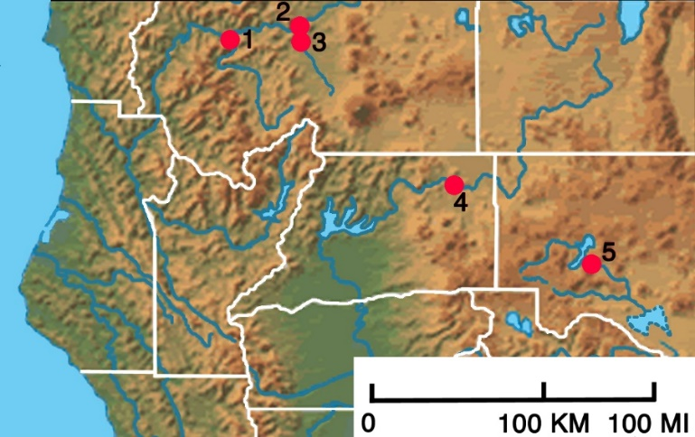

Randolph E. Collier Rest Area just downstream of the Interstate 5 (I-5) bridge crossing. However, we found *R. auricularia* at a number of other sites not discussed here in northern California and southern Oregon and it appears to be rapidly expanding its range throughout the western USA (personal observations of the authors). During the extensive surveys conducted by Deixis from 1993 to 1996, no populations of *Corbicula fluminea* were found in the upper Sacramento River system except in Shasta Lake in 1992. It

|  |  |  |  |  |  |  |  |  |  |  |
| --- | --- | --- | --- | --- | --- | --- | --- | --- | --- | --- |
| **Table 1.** Comparison of the mollusc fauna collected over a decade apart at four northern California streams. | | | | | | | | | | |
| **Scientific Name** | **Klamath**  **River** | | **Shasta**  **River** | | | **Pit**  **River** | | **Willow**  **Creek** | | |
|  | **2002** | **2013** | **1993** | | **2013** | **2001** | **2013** | **2001** | | **2012** |
| *Fluminicola* n. sp. 11 | x |  |  |  | |  |  |  | |  |
| *Fluminicola* n. sp. |  |  |  |  | |  |  | x | d | |
| *Fluminicola seminalis* |  |  |  |  | | x | x |  |  | |
| *Potamopyrgus antipodarum*2 |  | x |  |  | |  | x |  |  | |
| *Juga acutifilosa* |  |  |  |  | |  |  | x | x | |
| *Juga occata* |  |  |  |  | | x | x |  |  | |
| *Juga shastaensis* | x |  | x | d | |  |  |  |  | |
| *Vorticifex effusa* | x | x | x | d | | x | x | x | d | |
| *Gyraulus parvus* | x | x | x | d | | x | x | x |  | |
| *Planorbella tenuis* |  |  | x | d | |  |  | x | x | |
| *Galba parva* |  |  |  |  | | x | x |  |  | |
| *Lymnaea stagnalis* |  |  |  |  | |  |  | x | x | |
| *Lanx alta* | x | x | x | d | |  |  |  |  | |
| *Lanx patelloides* |  |  |  |  | | x | x |  |  | |
| *Radix auricularia*2 | x | x | x | d | |  |  | x | d | |
| *Haitia mexicana* | x | x |  |  | |  |  |  |  | |
| *Physella gyrina* | x | x | x | x | | x | x | x |  | |
| *Pisidium* spp. |  |  | x | x | |  |  |  |  | |
| *Pisidium lilljeborgii* | x | x | x | x | |  |  |  |  | |
| *Pisidium nitidum* | x | x | x | x | |  |  |  |  | |
| *Pisidium ultramontanum* |  |  |  |  | | x | x |  |  | |
| *Sphaerium patella* | x | x |  |  | |  |  |  |  | |
| *Sphaerium striatinum* | x | x |  |  | |  |  |  |  | |
| *Anodonta nuttalliana* |  |  |  |  | | x | x | x | d | |
| *Gonidea angulata* | x | x | x | d | | x | x |  |  | |
| *Corbicula fluminea*2 |  | x |  |  | |  | x |  |  | |
| **Total Native (live)**  **Total Introduced (live)** | **12**  **1** | **10**  **3** | **10**  **1** | **4**  **0** | | **10**  **0** | **10**  **2** | **8**  **1** | **3**  **0** | |
| 1 Klamath pebblesnail, federal Survey & Manage species (USDA & USDI, 1994); 2 introduced species; x live; d dead shells only | | | | | | | | | | |

was first reported in the Pit River in 2001 (USGS, 2015). Since then it has spread extensively in the Pit River system (pers. comm. Maria Ellis, 2013). *Corbicula* also appears to be expanding its range into a new river system as we record it for the first time from the Klamath River at the rest area. The first report of *Potamopyrgus antipodarum* in the upper Sacramento system was in the Pit Arm of Shasta Lake in 2007 (USGS, 2015). In 2013 we found *Potamopyrgus* for the first time in the Pit River above Shasta Lake at a fishing access under the State Route (SR) 299 bridge. *Potamopyrgus* was first noted at a lower Klamath River boat ramp in 2008 and in 2013 by us at the Randolph E. Collier Rest Area in the upper middle Klamath River (USGS, 2015).

We also noted a decline in the overall abundance and diversity of freshwater molluscs at four of the previously sampled sites (Table 1). Two species found in 2002, *Fluminicola* n. sp. 1 (Klamath pebblesnail), a Federal Survey and Manage species designated under the Northwest Forest Plan (Fig. 2; USDA & USDI, 1994), and *Juga shastaensis*, were not seen in the Klamath River at the Randolph Collier Rest Area in 2013. *Vorticifex effusa* and *Lanx alta*, two other cold-water sensitive species, continue to exist there but in very much reduced numbers. In the lower Shasta River about 2 km upstream of its junction with the Klamath River, we observed a significant decline in the molluscan fauna. Compared with the 1993 survey, in 2013 we found only four of the eleven formerly recorded species still living; of the others we only found long dead specimens in flood debris along the banks of the river (Table 1). Another site where we saw a significant decline in abundance and diversity from earlier surveys was at Willow Creek in the Honey Lake drainage (Great Basin), about 3.5 km south of Murrers Upper Meadow (spring source of the creek). In 2012 we found only three of the nine previously recorded species still living. In 2001, this site had a healthy population of *Anodonta nuttalliana* but we only found a few fragmentary valves. The once large population of *Juga acutifilosa* has also suffered a major decline, as we found hundreds of dead shells and only a small number of living individuals compared with previous samplings. An undescribed *Fluminicola* collected during the earlier survey from this site we found to be absent, but it still occurs in springs upstream, as does *Juga acutifilosa*.

In 2013, we sampled the Scott River near its junction with the Klamath River and saw only *Physella* along the river margin. But in a groundwater influenced, bedrock lined, side channel under the SR 96 bridge, we found a remnant mollusc fauna that included *Juga shastaensis*, *Margaritifera falcata* and *Anodonta nuttalliana*, as well as *Lanx alta*, *Gyraulus parvus*, *Planorbella tenuis*, *Haitia mexicana* and *Gonidea angulata*. Upstream of this site the river and tributaries were substantially reduced or dry from a combination of a number of factors including water diversions, extensive groundwater extraction for irrigation and a prolonged drought (Fig. 3).

The cause of the observed declines in the Pit and Klamath River sites is not as clear-cut as in the Scott River. We have learned subsequently that the Shasta River, like the Scott

River, had reached an all-time low flow in 2009. It was dewatered by a combination of drought and over-allocation of agricultural water diversions. As a result, the mollusc fauna has declined sharply. The reduction in flows and the increase in nutrients from agricultural and urban runoff in the drainage have clearly impacted the water quality and aquatic ecosystem of the Klamath River. At Willow Creek, an additional factor affecting this site is cattle grazing.

The Klamath River drainage had one of the most productive salmon fisheries on the west coast of the USA. In recent years there has been a concerted effort to restore the salmon runs by State and Federal agencies, but despite this, irrigators have continued unimpeded leading to substantial reduction of flows in the Scott River and more recently the Shasta River. Our 2012 and 2013 surveys have demonstraated the current dire condition of molluscs in the Klamath drainage and elsewhere in northern California. Recoveries for some species (e.g. *Lanx alta* and *Juga shastaensis*) in the Shasta River are unlikely, as currently no upstream populations are known. *Fluminicola* n. sp. 1 is an endemic species found in a small portion of the Klamath River system, occurring most abundantly in the Upper Klamath Lake (UKL) basin, Oregon (Fig. 2). But even here it is threatened by groundwater withdrawal. By 2014 the pre-2001 groundwater levels in the UKL basin had declined by about 6.1-7.6 m (Gannett & Breen, 2015). One of us (SC) has seen evidence of the impact from groundwater withdrawal in this basin at Big Springs, which was almost dewatered in 2013. This is one of the larger springs in the UKL basin and is used as a water source by the city of Bonanza. Three springsnail species (*Pyrgulopsis* n. sp. 2 and *Fluminicola* n. spp. 8 and 42) were found in this spring (Frest & Johannes, 1998). Impacts of groundwater withdrawal on other springs or streams in the UKL region are unknown. Despite obvious threats to *Fluminicola* n. sp. 1, this species along with other molluscs was recently rejected for listing under the Endangered Species Act (USFWS, 2012; Johannes, 2013). The demise of the *Anodonta nuttalliana* population in Willow Creek and *Gonidea angulata* in the Shasta River continues a decline seen in unionid populations in California (Howard *et al*., 2015).

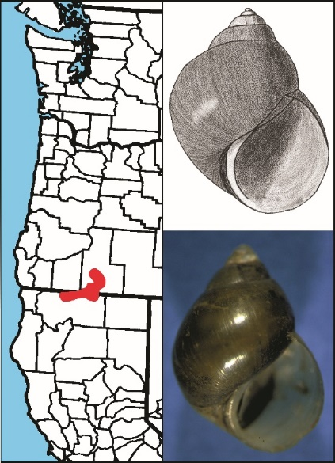

Fig. 2. *Fluminicola* n. sp. 1 (Klamath pebblesnail), a Federal Survey & Manage species. Occurrence in the Klamath drainage basin shown in red. Shell height: photo 8.6 mm; drawing 8.4 mm. (Photo: T. Frest © Deixis Consultants; drawing: E. Johannes © Deixis Consultants)

Our brief surveys have shown that there is a strong need to monitor the status of freshwater mollusc populations in the western USA. This is especially true now as the region has been enduring a prolonged drought and reduced snow pack while at the same time experiencing an unsustainable increase in groundwater extraction and water diversions.

We thank Richard Lis, California Department of Fish and Wildlife, Redding, for accompanying us in the field in 2013, Maria Ellis, Spring Rivers Ecological Sciences LLC, Cassell, for specimens from and discussions on molluscs in the Pit River and Kerul Dyer, Klamath Riverkeeper, Somes Bar, for photos of the Scott River.

Fig. 3. The dry Scott River in 2014. Note vehicle tracks in the riverbed and fields being irrigated. (Photo: Klamath River Keeper).

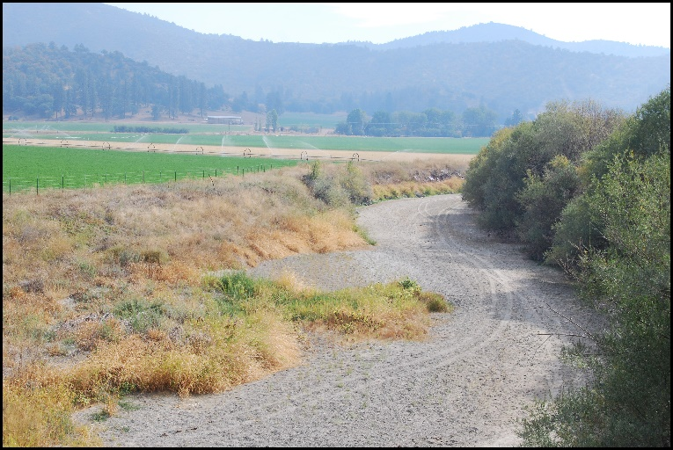

Frest, T.J. & Johannes, E.J. 1993. Freshwater molluscs of the Upper Sacramento System, California, with particular reference to the Cantara Spill. 1992 yearly report to California Department of Fish and Game, Redding, California. iv + 101 p., appendices.

Frest, T.J. & Johannes, E.J. 1994. Freshwater molluscs of the Upper Sacramento System, California, with particular reference to the Cantara Spill. 1993 yearly report to California Department of Fish and Game, Redding, California. ii + 57 p., appendices.

Frest, T.J. & Johannes, E.J. 1995. Freshwater molluscs of the Upper Sacramento System, California, with particular reference to the Cantara Spill. 1994 yearly report to California Department of Fish and Game, Redding, California. Deixis Consultants. iii + 88 p., appendices.

Frest, T.J. & Johannes, E.J. 1997. Upper Sacramento System freshwater mollusks monitoring, California. 1996 yearly report to Cantara Trustee Council, Redding, California. Deixis Consultants. iii + 39 p., appendices.

Frest, T.J. & Johannes, E.J. 1998. Freshwater mollusks of the Upper Klamath Drainage, Oregon. 1998 yearly report to Oregon Natural Heritage Program, Portland, Oregon, and Klamath Project, U.S. Department of the Interior, Bureau of Reclamation, Klamath Falls, Oregon. Deixis Consultants. vii + 200 p., appendices.

Gannett, M.W. & Breen, K.H. 2015. Groundwater levels, trends, and relations to pumping in the Bureau of Reclamation Klamath Project, Oregon and California. [*U.S. Geological Survey Open-File Report* 2015-1145](http://pubs.usgs.gov/of/2015/1145/ofr20151145.pdf). iv + 19 p.

Howard, J.K., Furnish, J.L., Brim Box, J. & Jepsen, S. 2015. The decline of native freshwater mussels (Bivalvia: Unionoida) in California as determined from historical and current surveys. [*California Fish and Game* 101](https://nrm.dfg.ca.gov/FileHandler.ashx?DocumentID=99811): 8-23.

Johannes, E.J. 2013. U.S. Fish and Wildlife Service rejects 14 of 26 Pacific Northwest snails and slugs proposed for listing and sets a dangerous precedent. [*Tentacle* 21](http://www.hawaii.edu/cowielab/Tentacle/Tentacle_21.pdf): 23-26.

USDA & USDI. 1994. [*Record of decision for amendments to Forest Service and Bureau of Land Management planning documents within the range of the Northern Spotted Owl*](http://www.reo.gov/riec/newroda.pdf)*.* [*Standards and guidelines for management of habitat for late-successional and old-growth forest related species within the range of the Northern Spotted Owl*.](http://www.reo.gov/library/reports/newsandga.pdf) U.S. Forest Service, Portland, Oregon. ii + 74, viii + 144 p.

USFWS. 2012. Endangered and threatened wildlife and plants; 12-month finding on a petition to list 14 aquatic mollusks as endangered or threatened; proposed rule. [*Federal Register* 77](http://www.gpo.gov/fdsys/pkg/FR-2012-09-18/pdf/2012-22723.pdf): 57922-57948.

USGS. 2015. [NAS-Nonindigenous Aquatic Species](http://nas.er.usgs.gov/default.aspx).

Edward J. Johannes, Deixis Consultants, 16827 51st Avenue South, SeaTac, Washington 98188-3245, USA. [edjohannes@yahoo.com](mailto:edjohannes@yahoo.com)

Stephanie A. Clark, Invertebrate Identification Australasia, 6535 N Mozart Street, Apt 3F, Chicago, Illinois 60645-4339, USA. [meridiolum@ozemail.com.au](mailto:meridiolum@ozemail.com.au)